1. Write a Python program to print the following string in a specific format (see the output).

Twinkle, twinkle, little star,

How I wonder what you are!

Up above the world so high,

Like a diamond in the sky.

Twinkle, twinkle, little star,

How I wonder what you are

**Program#1:**

print("Twinkle, twinkle, little star,")

print(" How I wonder what you are!")

print(" Up above the world so high,")

print(" Like a diamond in the sky.")

print("Twinkle, twinkle, little star,")

print(" How I wonder what you are")

**Output:**

Twinkle, twinkle, little star,

How I wonder what you are!

Up above the world so high,

Like a diamond in the sky.

Twinkle, twinkle, little star,

How I wonder what you are

**Image and Link,**

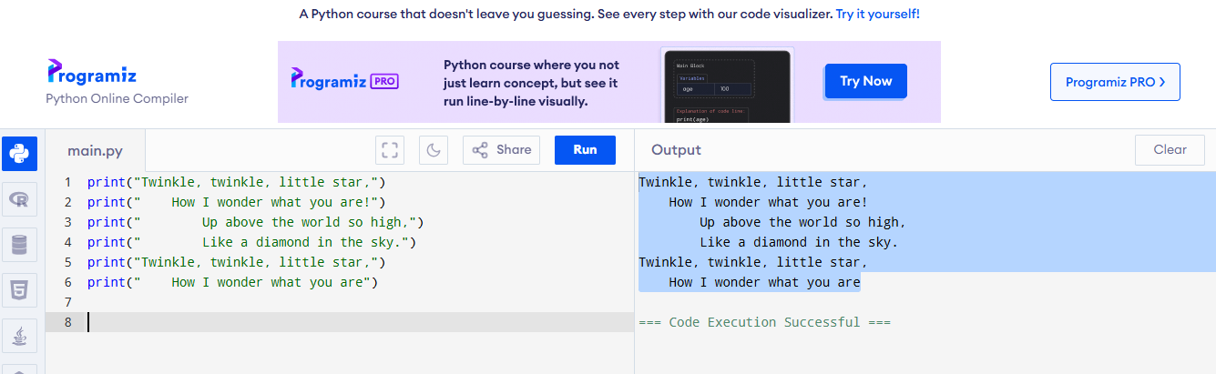

<https://www.programiz.com/online-compiler/2hbVx8RV1qJwz>

**Program#2:**

print("Twinkle, twinkle, little star,\n How I wonder what you are!\n Up above the world so high,\n Like a diamond in the sky.\nTwinkle, twinkle, little star,\n How I wonder what you are")

**Output:**

Twinkle, twinkle, little star,

How I wonder what you are!

Up above the world so high,

Like a diamond in the sky.

Twinkle, twinkle, little star,

How I wonder what you are

**Image and Link:**

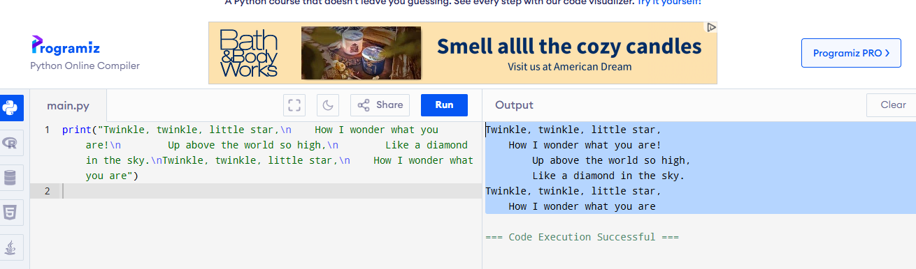

<https://www.programiz.com/online-compiler/8lKj1EuSHX2wa>